How to Make Terminal Look like Kali Linux
Last updated: December 22, 2022
- Operating System
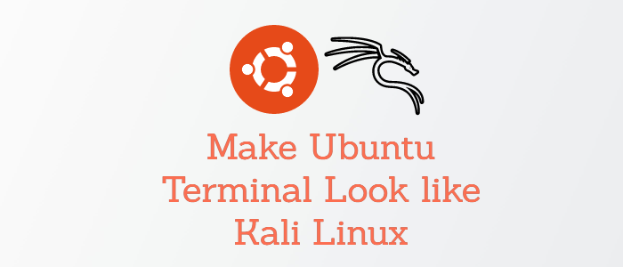
Kali Linux and Ubuntu are the two most popular Linux distributions. Ubuntu is a general-purpose Linux distribution that is popular among developers and students, though it is not limited to these groups, whereas Kali Linux is popular in the world of cybersecurity and ethical hacking.
There are a few visual differences between the Ubuntu terminal and the Kali Linux terminal. While the default Ubuntu terminal is functional, sometimes Ubuntu users may prefer the look of the Kali Linux terminal. In this guide, we learn how to make your Ubuntu terminal look like Kali Linux terminal.

1. Installing required packages
The first step in making your Ubuntu terminal look like Kali's is to install zsh shell, zshell plugins and some additional tools if not already pre-installed

Installing ZSH on Ubuntu
The Z shell is a Unix shell that was developed as an extension to BASH (Bourne shell) in the early 90s. Z shell is an interactive shell that incorporates many features of other Unix/GNU Linux shells like bash, fish, dash and ksh.
It also has a powerful scripting language, just like the other shells. Despite this, it has some distinguishing characteristics, which include:
- Autocomplete for command names
- spelling corrections.
- Extensible via plugins.
- running shells can share the same history.
- supports several compatibility modes.
- Better variable and array handling.
- support themes
- Create filenames based on the conditions you provide.
Before installing z shell, you must first update your system by running the following command:
sudo apt update
After successfully updating your system, run the following command to install zshell.
sudo apt install zsh
Once zsh has been installed, simply run the zsh command to switch from the bash prompt to the zsh prompt. When you run the command, you will see a z shell configuration prompt (select option zero from the prompt and hit enter to apply)
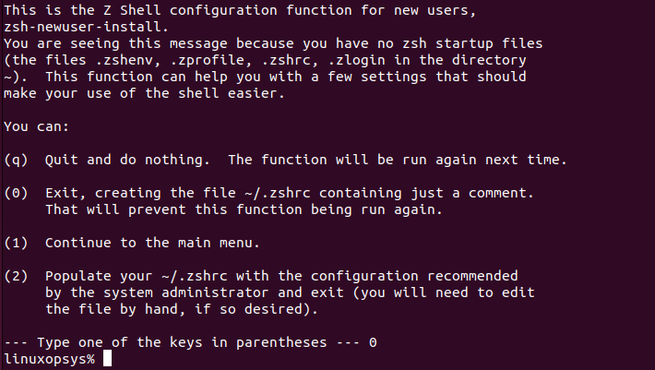

Installing zshell plugins
Next, we'll need to install a few z shell plugins to add some useful functionality to our z shell. Here are the three plugins that will be installed.
- zsh-syntax-highlighting - This plugin highlights syntax in the z shell. It allows command highlighting when typing at a z shell prompt. This is useful for reviewing commands before running them, notably in spotting syntax errors.
- zsh-autosuggestions - this plugin suggests commands to you as you enter them based on your previous commands and completions.
Open your Ubuntu terminal and type the following command:
sudo apt install zsh-syntax-highlighting zsh-autosuggestions
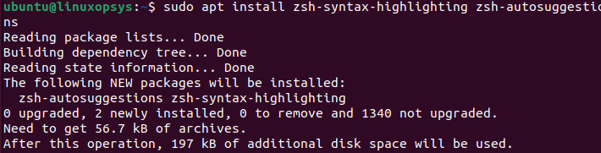
This command will download and install all of the z shell plugins listed.

Installing fonts, qterminal and gnome-tweaks
The last things you need to install are:
- qterminal - a lightweight Qt terminal emulator based on QTermWidget, by default Ubuntu uses gnome terminal.
- fonts-firacode - a free monospaced font with ligatures for common multi-character programming combinations.
- gnome-tweaks - this is a must-have tool for any GNOME user. It allows you to customize the appearance and functionality of your desktop.
To install all these run the following command:
sudo apt install qterminal fonts-firacode gnome-tweaks
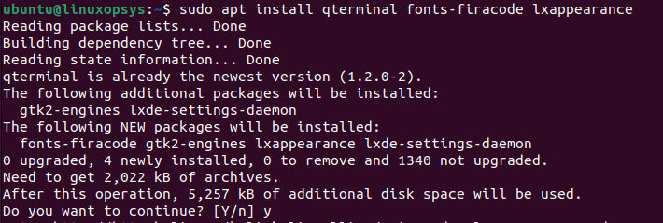

2. Changing the default login shell
Now that you've installed z shell and its plugins, you'll need to make it your default login shell. To accomplish so, we'll use the chsh (change shell) command. chsh is a powerful tool used to change a login shell. There is no need to install the chsh command because it is a standard package that comes pre-installed on all Linux distributions.
Run the following command to change your default login shell to z shell:
Please keep in mind that this command will permanently change your default login shell to the one you specify.
chsh -s /bin/zsh
Before you can make any changes, you must first enter your username password. Log out and then back in to see the changes; the bash prompt will be replaced with the zsh prompt.
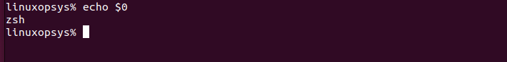

3. Customizing ubuntu zshell
Now that you've installed all of the tools needed to customize your Ubuntu terminal. It's time to start customizing your Ubuntu terminal. Follow these steps to accomplish it.

Step 1. Modifying the zshrc file
You need to tweak the zshrc file in order to customize it's appearance. This file is a hidden file in your home directory (~/.zshrc). The .zshrc file is a startup file equivalent for bashrc file for bash (Bourne Again shell) that is used to customize and configure the z shell.
This file may not be available at times, so you must create it; if it is already available, delete it and create a new one because you will need to override its contents.
To delete the file run the following command:
rm ~/.zshrc
and to create a new file simply run this command:
touch ~/.zshrc
After you have successfully created the .zshrc file, open it with your preferred text editor, copy and paste the contents of this pastebin into your .zshrc file, and save.
To make the changes take effect, source your .zshrc file with the source or dot (.) command, or simply close and reopen your terminal.
$ source .zshrc
$ . .zshrc
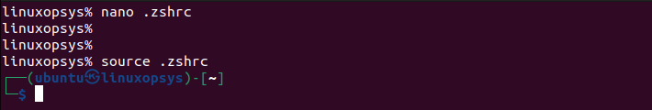

Step 2. Downloading color schemes and themes
Next clone the compressed kali linux color schemes and themes from. To do so run this command:
git clone https://github.com/linuxopsys/ubuntu-to-kali-terminal.git
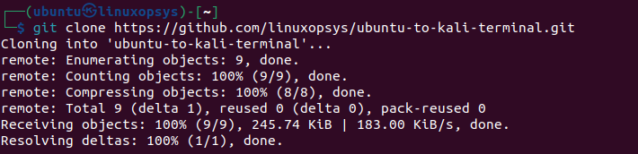
Once the repository has been cloned, cd into it.
cd ubuntu-to-kali-terminal
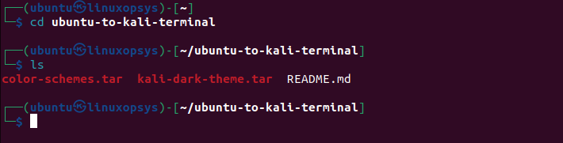
Next, extract the compressed files, once you have extracted all the files you will notice a new directory name "usr" in your current working directory.
tar -xvf color-schemes.tar
tar -xvf kali-dark-theme.tar
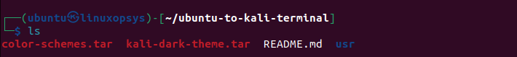
You must now remove the qtermwidget5 directory located in the /usr/share directory and replace it with one from the extracted tar file.
sudo rm -rf /usr/share/qtermwidget5
sudo mv -f usr/share/qtermwidget5 /usr/share
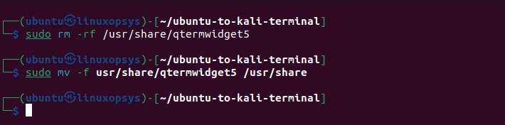

Step 3. Changing Qterminal settings
Open your Qterminal preferences: Change the color scheme to Kali-Dark and then press the Apply button, this will change the terminal theme to that one of Kali. Also, at the bottom of your terminal's Appearance settings, adjust the "Application transparency" from "0%" to "5%," the same as on Kali, and click apply for the changes to take effect.
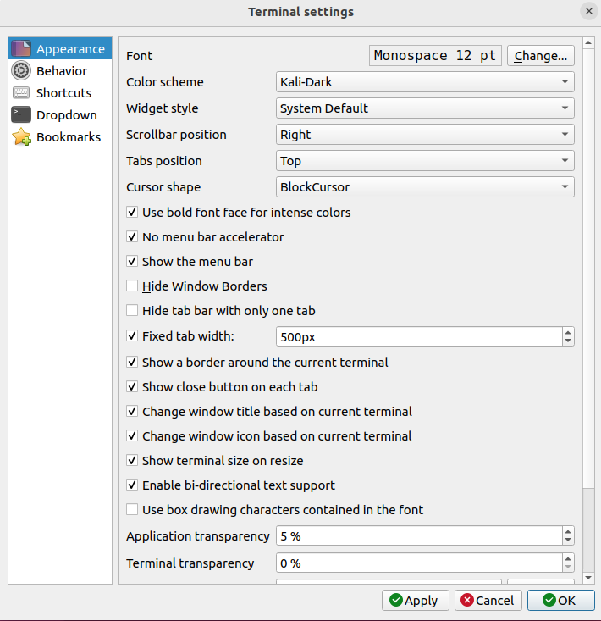
After you've made the changes, your qterminal should look like this:
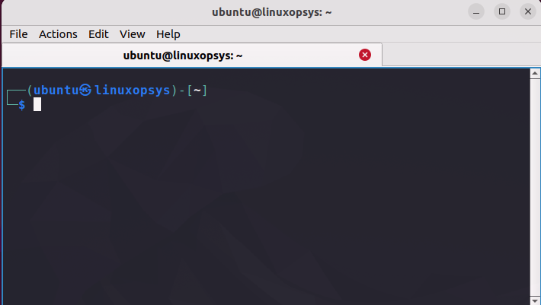
All that remains is to change your entire system theme, which can be accomplished by moving the Kali-Dark directory from the directory you previously extracted to /usr/share/themes directory.
sudo mv -f usr/share/themes/Kali-Dark /usr/share/themes

# CONTEUDO DO ARQUIVO “.zshrc” :

# ~/.zshrc file for zsh interactive shells.
# see /usr/share/doc/zsh/examples/zshrc for examples

setopt autocd # change directory just by typing its name
#setopt correct # auto correct mistakes
setopt interactivecomments # allow comments in interactive mode
setopt magicequalsubst # enable filename expansion for arguments of the form ‘anything=expression’
setopt nonomatch # hide error message if there is no match for the pattern
setopt notify # report the status of background jobs immediately
setopt numericglobsort # sort filenames numerically when it makes sense
setopt promptsubst # enable command substitution in prompt

WORDCHARS=${WORDCHARS//\/} # Don't consider certain characters part of the word

# hide EOL sign ('%')
PROMPT_EOL_MARK=""

# configure key keybindings
bindkey -e # emacs key bindings
bindkey ' ' magic-space # do history expansion on space
bindkey '^U' backward-kill-line # ctrl + U
bindkey '^[[3;5~' kill-word # ctrl + Supr
bindkey '^[[3~' delete-char # delete
bindkey '^[[1;5C' forward-word # ctrl + ->
bindkey '^[[1;5D' backward-word # ctrl + <-
bindkey '^[[5~' beginning-of-buffer-or-history # page up
bindkey '^[[6~' end-of-buffer-or-history # page down
bindkey '^[[H' beginning-of-line # home
bindkey '^[[F' end-of-line # end
bindkey '^[[Z' undo # shift + tab undo last action

# enable completion features
autoload -Uz compinit
compinit -d ~/.cache/zcompdump
zstyle ':completion:*:*:*:*:*' menu select
zstyle ':completion:*' auto-description 'specify: %d'
zstyle ':completion:*' completer _expand _complete
zstyle ':completion:*' format 'Completing %d'
zstyle ':completion:*' group-name ''
zstyle ':completion:*' list-colors ''
zstyle ':completion:*' list-prompt %SAt %p: Hit TAB for more, or the character to insert%s
zstyle ':completion:*' matcher-list 'm:{a-zA-Z}={A-Za-z}'
zstyle ':completion:*' rehash true
zstyle ':completion:*' select-prompt %SScrolling active: current selection at %p%s
zstyle ':completion:*' use-compctl false
zstyle ':completion:*' verbose true
zstyle ':completion:*:kill:*' command 'ps -u $USER -o pid,%cpu,tty,cputime,cmd'

# History configurations
HISTFILE=~/.zsh_history
HISTSIZE=1000
SAVEHIST=2000
setopt hist_expire_dups_first # delete duplicates first when HISTFILE size exceeds HISTSIZE
setopt hist_ignore_dups # ignore duplicated commands history list
setopt hist_ignore_space # ignore commands that start with space
setopt hist_verify # show command with history expansion to user before running it
#setopt share_history # share command history data

# force zsh to show the complete history
alias history="history 0"

# configure `time` format
TIMEFMT=$'\nreal\t%E\nuser\t%U\nsys\t%S\ncpu\t%P'

# make less more friendly for non-text input files, see lesspipe(1)
#[ -x /usr/bin/lesspipe ] && eval "$(SHELL=/bin/sh lesspipe)"

# set variable identifying the chroot you work in (used in the prompt below)
if [ -z "${debian_chroot:-}" ] && [ -r /etc/debian_chroot ]; then
debian_chroot=$(cat /etc/debian_chroot)
fi

# set a fancy prompt (non-color, unless we know we "want" color)
case "$TERM" in
xterm-color|*-256color) color_prompt=yes;;
esac

# uncomment for a colored prompt, if the terminal has the capability; turned
# off by default to not distract the user: the focus in a terminal window
# should be on the output of commands, not on the prompt
force_color_prompt=yes

if [ -n "$force_color_prompt" ]; then
if [ -x /usr/bin/tput ] && tput setaf 1 >&/dev/null; then
# We have color support; assume it's compliant with Ecma-48
# (ISO/IEC-6429). (Lack of such support is extremely rare, and such
# a case would tend to support setf rather than setaf.)
color_prompt=yes
else
color_prompt=
fi
fi

configure_prompt() {
prompt_symbol=㉿
# Skull emoji for root terminal
#[ "$EUID" -eq 0 ] && prompt_symbol=💀
case "$PROMPT_ALTERNATIVE" in
twoline)
PROMPT=$'%F{%(#.blue.green)}┌──${debian_chroot:+($debian_chroot)─}${VIRTUAL_ENV:+($(basename $VIRTUAL_ENV))─}(%B%F{%(#.red.blue)}%n'$prompt_symbol$'%m%b%F{%(#.blue.green)})-[%B%F{reset}%(6~.%-1~/…/%4~.%5~)%b%F{%(#.blue.green)}]\n└─%B%(#.%F{red}#.%F{blue}$)%b%F{reset} '
# Right-side prompt with exit codes and background processes
#RPROMPT=$'%(?.. %? %F{red}%B⨯%b%F{reset})%(1j. %j %F{yellow}%B⚙%b%F{reset}.)'
;;
oneline)
PROMPT=$'${debian_chroot:+($debian_chroot)}${VIRTUAL_ENV:+($(basename $VIRTUAL_ENV))}%B%F{%(#.red.blue)}%n@%m%b%F{reset}:%B%F{%(#.blue.green)}%~%b%F{reset}%(#.#.$) '
RPROMPT=
;;
backtrack)
PROMPT=$'${debian_chroot:+($debian_chroot)}${VIRTUAL_ENV:+($(basename $VIRTUAL_ENV))}%B%F{red}%n@%m%b%F{reset}:%B%F{blue}%~%b%F{reset}%(#.#.$) '
RPROMPT=
;;
esac
unset prompt_symbol
}

# The following block is surrounded by two delimiters.
# These delimiters must not be modified. Thanks.
# START KALI CONFIG VARIABLES
PROMPT_ALTERNATIVE=twoline
NEWLINE_BEFORE_PROMPT=yes
# STOP KALI CONFIG VARIABLES

if [ "$color_prompt" = yes ]; then
# override default virtualenv indicator in prompt
VIRTUAL_ENV_DISABLE_PROMPT=1

configure_prompt

# enable syntax-highlighting
if [ -f /usr/share/zsh-syntax-highlighting/zsh-syntax-highlighting.zsh ]; then
. /usr/share/zsh-syntax-highlighting/zsh-syntax-highlighting.zsh
ZSH_HIGHLIGHT_HIGHLIGHTERS=(main brackets pattern)
ZSH_HIGHLIGHT_STYLES[default]=none
ZSH_HIGHLIGHT_STYLES[unknown-token]=fg=white,underline
ZSH_HIGHLIGHT_STYLES[reserved-word]=fg=cyan,bold
ZSH_HIGHLIGHT_STYLES[suffix-alias]=fg=green,underline
ZSH_HIGHLIGHT_STYLES[global-alias]=fg=green,bold
ZSH_HIGHLIGHT_STYLES[precommand]=fg=green,underline
ZSH_HIGHLIGHT_STYLES[commandseparator]=fg=blue,bold
ZSH_HIGHLIGHT_STYLES[autodirectory]=fg=green,underline
ZSH_HIGHLIGHT_STYLES[path]=bold
ZSH_HIGHLIGHT_STYLES[path_pathseparator]=
ZSH_HIGHLIGHT_STYLES[path_prefix_pathseparator]=
ZSH_HIGHLIGHT_STYLES[globbing]=fg=blue,bold
ZSH_HIGHLIGHT_STYLES[history-expansion]=fg=blue,bold
ZSH_HIGHLIGHT_STYLES[command-substitution]=none
ZSH_HIGHLIGHT_STYLES[command-substitution-delimiter]=fg=magenta,bold
ZSH_HIGHLIGHT_STYLES[process-substitution]=none
ZSH_HIGHLIGHT_STYLES[process-substitution-delimiter]=fg=magenta,bold
ZSH_HIGHLIGHT_STYLES[single-hyphen-option]=fg=green
ZSH_HIGHLIGHT_STYLES[double-hyphen-option]=fg=green
ZSH_HIGHLIGHT_STYLES[back-quoted-argument]=none
ZSH_HIGHLIGHT_STYLES[back-quoted-argument-delimiter]=fg=blue,bold
ZSH_HIGHLIGHT_STYLES[single-quoted-argument]=fg=yellow
ZSH_HIGHLIGHT_STYLES[double-quoted-argument]=fg=yellow
ZSH_HIGHLIGHT_STYLES[dollar-quoted-argument]=fg=yellow
ZSH_HIGHLIGHT_STYLES[rc-quote]=fg=magenta
ZSH_HIGHLIGHT_STYLES[dollar-double-quoted-argument]=fg=magenta,bold
ZSH_HIGHLIGHT_STYLES[back-double-quoted-argument]=fg=magenta,bold
ZSH_HIGHLIGHT_STYLES[back-dollar-quoted-argument]=fg=magenta,bold
ZSH_HIGHLIGHT_STYLES[assign]=none
ZSH_HIGHLIGHT_STYLES[redirection]=fg=blue,bold
ZSH_HIGHLIGHT_STYLES[comment]=fg=black,bold
ZSH_HIGHLIGHT_STYLES[named-fd]=none
ZSH_HIGHLIGHT_STYLES[numeric-fd]=none
ZSH_HIGHLIGHT_STYLES[arg0]=fg=cyan
ZSH_HIGHLIGHT_STYLES[bracket-error]=fg=red,bold
ZSH_HIGHLIGHT_STYLES[bracket-level-1]=fg=blue,bold
ZSH_HIGHLIGHT_STYLES[bracket-level-2]=fg=green,bold
ZSH_HIGHLIGHT_STYLES[bracket-level-3]=fg=magenta,bold
ZSH_HIGHLIGHT_STYLES[bracket-level-4]=fg=yellow,bold
ZSH_HIGHLIGHT_STYLES[bracket-level-5]=fg=cyan,bold
ZSH_HIGHLIGHT_STYLES[cursor-matchingbracket]=standout
fi
else
PROMPT='${debian_chroot:+($debian_chroot)}%n@%m:%~%(#.#.$) '
fi
unset color_prompt force_color_prompt

toggle_oneline_prompt(){
if [ "$PROMPT_ALTERNATIVE" = oneline ]; then
PROMPT_ALTERNATIVE=twoline
else
PROMPT_ALTERNATIVE=oneline
fi
configure_prompt
zle reset-prompt
}
zle -N toggle_oneline_prompt
bindkey ^P toggle_oneline_prompt

# If this is an xterm set the title to user@host:dir
case "$TERM" in
xterm*|rxvt*|Eterm|aterm|kterm|gnome*|alacritty)
TERM_TITLE=$'\e]0;${debian_chroot:+($debian_chroot)}${VIRTUAL_ENV:+($(basename $VIRTUAL_ENV))}%n@%m: %~\a'
;;
*)
;;
esac

precmd() {
# Print the previously configured title
print -Pnr -- "$TERM_TITLE"

# Print a new line before the prompt, but only if it is not the first line
if [ "$NEWLINE_BEFORE_PROMPT" = yes ]; then
if [ -z "$_NEW_LINE_BEFORE_PROMPT" ]; then
_NEW_LINE_BEFORE_PROMPT=1
else
print ""
fi
fi
}

# enable color support of ls, less and man, and also add handy aliases
if [ -x /usr/bin/dircolors ]; then
test -r ~/.dircolors && eval "$(dircolors -b ~/.dircolors)" || eval "$(dircolors -b)"
export LS_COLORS="$LS_COLORS:ow=30;44:" # fix ls color for folders with 777 permissions

alias ls='ls --color=auto'
#alias dir='dir --color=auto'
#alias vdir='vdir --color=auto'

alias grep='grep --color=auto'
alias fgrep='fgrep --color=auto'
alias egrep='egrep --color=auto'
alias diff='diff --color=auto'
alias ip='ip --color=auto'

export LESS_TERMCAP_mb=$'\E[1;31m' # begin blink
export LESS_TERMCAP_md=$'\E[1;36m' # begin bold
export LESS_TERMCAP_me=$'\E[0m' # reset bold/blink
export LESS_TERMCAP_so=$'\E[01;33m' # begin reverse video
export LESS_TERMCAP_se=$'\E[0m' # reset reverse video
export LESS_TERMCAP_us=$'\E[1;32m' # begin underline
export LESS_TERMCAP_ue=$'\E[0m' # reset underline

# Take advantage of $LS_COLORS for completion as well
zstyle ':completion:*' list-colors "${(s.:.)LS_COLORS}"
zstyle ':completion:*:*:kill:*:processes' list-colors '=(#b) #([0-9]#)*=0=01;31'
fi

# some more ls aliases
alias ll='ls -l'
alias la='ls -A'
alias l='ls -CF'

# enable auto-suggestions based on the history
if [ -f /usr/share/zsh-autosuggestions/zsh-autosuggestions.zsh ]; then
. /usr/share/zsh-autosuggestions/zsh-autosuggestions.zsh
# change suggestion color
ZSH_AUTOSUGGEST_HIGHLIGHT_STYLE='fg=#999'
fi

# enable command-not-found if installed
if [ -f /etc/zsh_command_not_found ]; then
. /etc/zsh_command_not_found
fi
compinit

FONTE:
https://linuxopsys.com/topics/make-ubuntu-terminal-look-like-kali-linux

